**DESIGN PROJECT REPORT**

**ENGR 131- Transforming Ideas to Innovation I**

Section 012

Campus Mobility Design

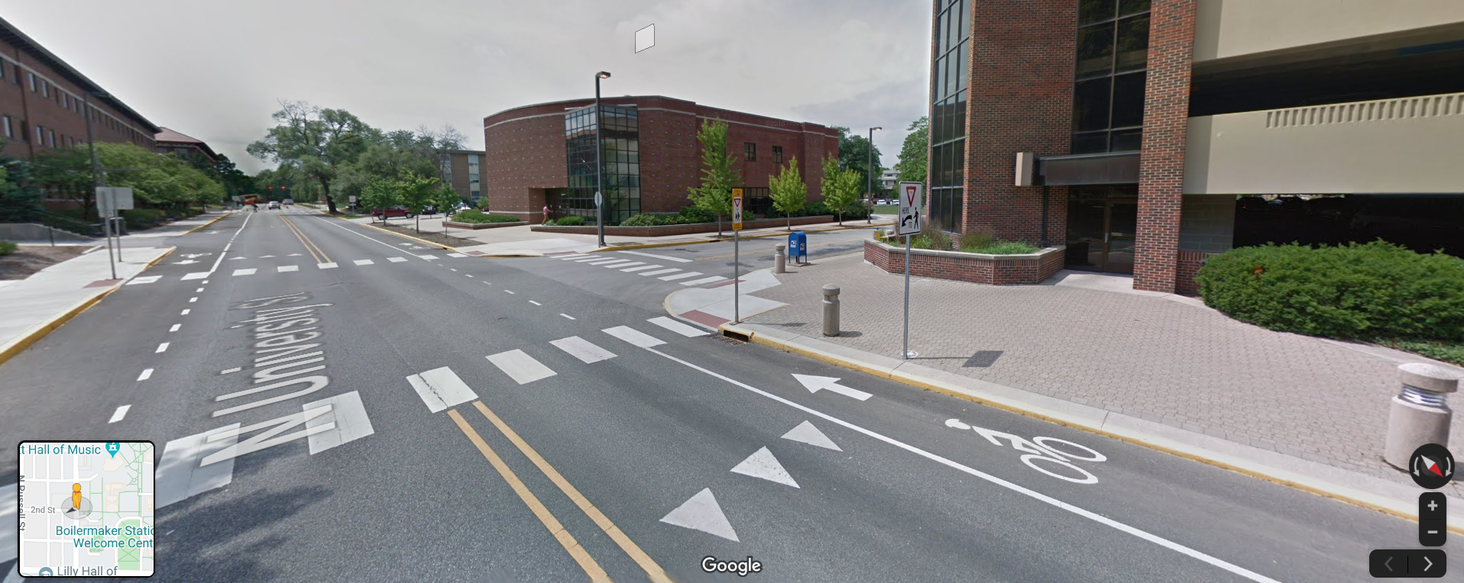

Team 10

Gonzalo Alonso Novo

Jared Seltzer

Pieter Jackson

Andrew Simmes

10/25/2019

# Executive Summary

Purdue University assigned our team the task of developing a system to decrease the number of accidents on a specific part of campus. More specifically, we were assigned the intersection between Second and University Street. We will attempt to find the most desirable and effective solution, while at the same time being economically and technically feasible. The biggest challenges when creating the model are to maintain a low budget, and use the available technologies, while at the same time helping decrease the amount of accidents in that zone. We found that a combination of using a stop light and pedestrian railings was the best solution overall. Currently there are only 2 yield signs and a stop sign, making it difficult for pedestrians to safely cross the street. By adding a stop light, we create a set time for pedestrians to cross so that they can cross safely. In addition, by adding pedestrian railings we will help prevent J-walking.

1. **Contents**

I. Executive Summary 2

III. TEAM MEMBER ROLES 4

IV. PROBLEM SCOPING 5

a. Problem Statement 5

b. Design Criteria and Constraints 5

c. Direct Users and Stakeholders 5

d. Background Information 6

e. Assumptions about the Problem 6

V. IDEA GENERATION & THOUGHT EXPERIMENTS 6

a. Functional Decomposition 6

b. Exploring Prior Art 7

c. Sketching 8

d. Low Fidelity Prototyping 8

e. Biomimicry 8

f. Thought Experiments with Pros and Cons Evaluation 9

VI. ITERATION #1 9

VII. PROTOTYPING, TESTING AND WDM 10

a. Prototypes 10

b. Prototype Testing Protocol 10

c. Test Results for Top 3 Alternatives 10

d. Weighted Decision Matrix (WDM) 11

VIII. ITERATION #2 11

IX. OVERVIEW OF FINAL DESIGN 11

a. Detailed Design 11

b. Data on Final Solution 12

d. Novel Aspects of the Solution 12

e. Trade-off Decisions and Limitations of the Solution 12

f. Lessons Learned 12

X. REFERENCES 13

XI. APPENDICES 13

# TEAM MEMBER ROLES

Our project team included 4 members (See Figure 1). We allocated roles and responsibilities to each team member by/based on….

*Table 1. Team roles*

|  |  |  |
| --- | --- | --- |
| **Project milestones** | **Name** | **Specific responsibilities related to each milestone** |
| Problem scoping | Gonzalo Alonso  Jared Seltzer  Andrew Simmes  Pieter Jackson | * Cover Page, Part IV A, * Part IV, D&E * Part IV, B * Prt IV, C |
| Idea generation | Gonzalo Alonso  Jared Seltzer  Andrew Simmes  Pieter Jackson | * V, Part F,E and Part VI * V, Part B & D * V, Part C * V, Part A |
| Prototyping | Gonzalo Alonso  Andrew Simmes  Pieter Jackson  Jared Seltzer | VI - a  VI - b,c |
| Testing | Gonzalo Alonso  Andrew Simmes  Pieter Jackson  Jared Seltzer | As a group, we all contributed on the testing phase of this project, going to different locations to see the amount of traffic and other features on each spot |
| WDM | Andrew Simmes | Created the WDM with the help of the team. |
| Preliminary presentation | Gonzalo Alonso  Andrew Simmes  Pieter Jackson  Jared Seltzer | We created the presentation as a team based on what the rubric asked for |
| Iteration | Gonzalo Alonso  Andrew Simmes  Pieter Jackson  Jared Seltzer |  |
| Final report | Gonzalo Alonso  Andrew Simmes  Pieter Jackson  Jared Seltzer | We all corrected the report based on the previous feedback |
| Final presentation | Gonzalo Alonso  Andrew Simmes  Pieter Jackson  Jared Seltzer | We all made changes to the presentation based on the previous feedback |

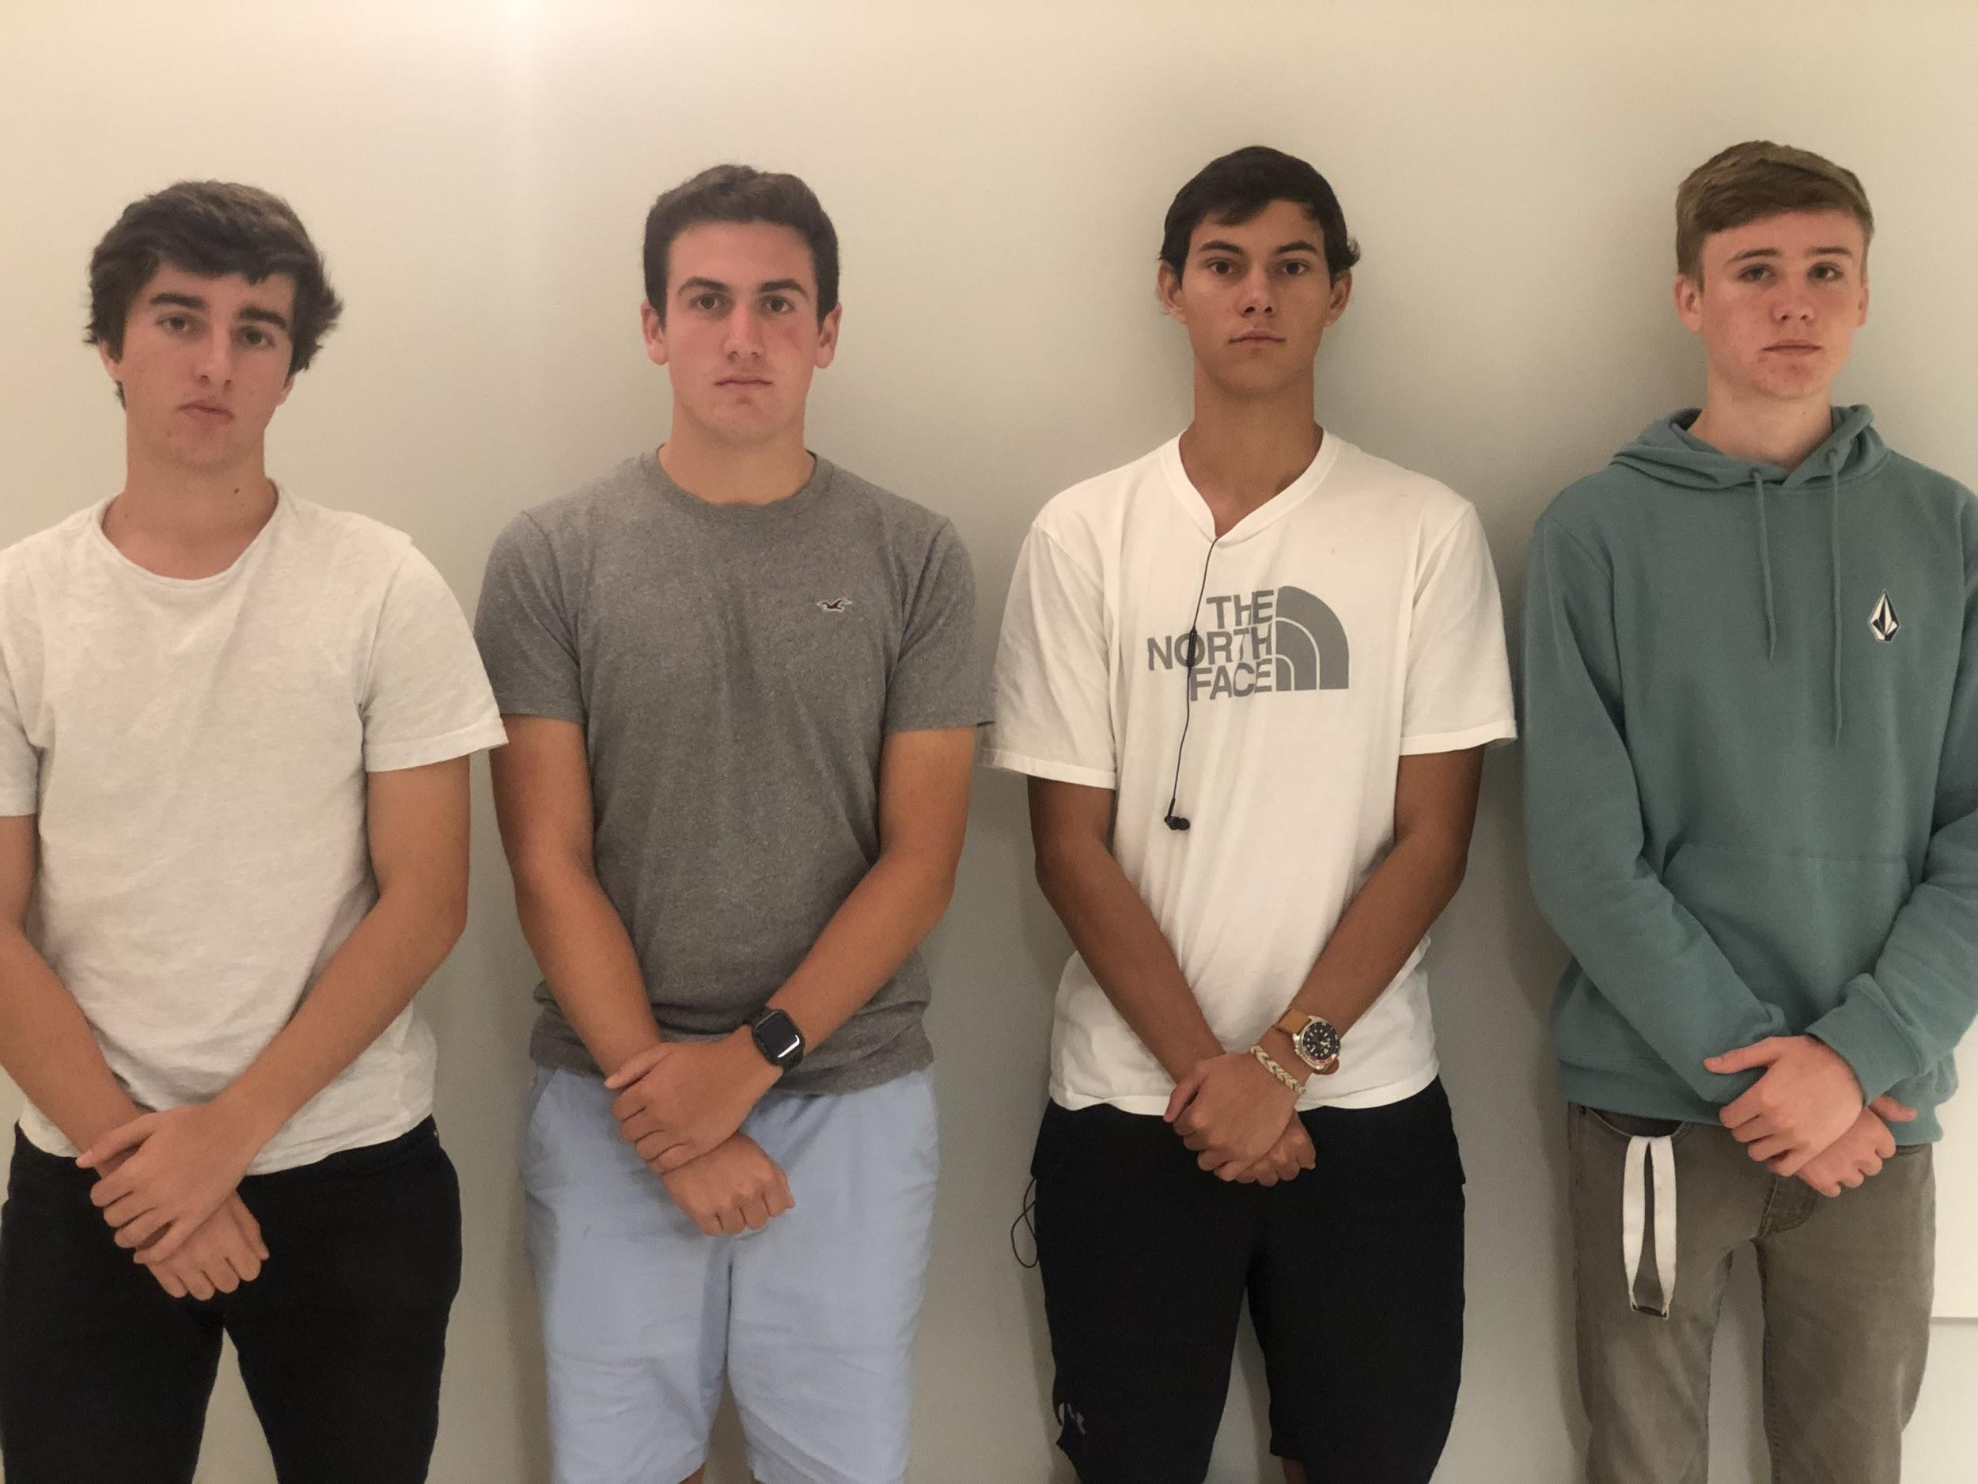

*Figure 1. Project team*

# PROBLEM SCOPING

## Problem Statement

We were assigned to create a design that decreases the number of accidents in the Purdue University campus, specifically the intersection between Second and University Street. At Purdue, thousands of people transit the streets on campus every day, thus creating a design to decrease accidents is something urgent. This recurring theme comes from the concerns raised with the coexisting of different modes of transportation, such as cars, bikes, pedestrians, etc. We were requested to find a desirable and effective solution, while spending as little as possible and using affordable technologies.

## Design Criteria and Constraints

*Table 2. Design requirements*

|  |  |  |
| --- | --- | --- |
| **Criteria and Constraints** | **Metrics (ways to quantify and measure the performance of your solutions and measure success)** | **Metric units** |
| Improve the safety of campus mobility at our intercession. | Amounts of accidents/incidents at the intersection per unit time through direct observation. | accidents/ minute or accidents/ hour |
| Use signage, structures, or devices. | Are their signs, structures, or devices used to solve the issue presented. | Yes or No |
| Integrate into the surroundings easily. | Compare to other similar locations around the campus. | Categorical scale of from very common to uncommon usage around campus |
| Be cost effective. | Estimated cost based on building materials and labor. | dollars |

There will be some tradeoffs between the solution being very safe and price: we are trying to find a solution to a traffic intersection so there is a possibility that we can’t have both criteria. Also increasing the usage of signage and devices in the traffic stop may make it too complicated for users and may compromise safety.

## Direct Users and Stakeholders

*Table 3. Empathizing with users*

|  |  |  |
| --- | --- | --- |
| **User segment (include an image and a label)** | **Methods used to empathize with the user (interview user, survey user, observe user, read about user, simulate user behavior, put yourself in his/her shoes)** | **Lessons learned from this interaction** |
| Pedestrian | Put in user’s shoes | If I was a student, I would definitely want to get to my dorm as soon as possible so I would take any and all opportunities to cross the street to start my journey back home, even if it means the cars have to wait a while. Having a way to cross ASAP without disturbing traffic flow would be great. |
| Driver | Observe User | Waiting for Students to cross the street takes a long time, especially when it is a passing period. A spread out group often crosses, then a straggler or 2 cross after the group but timed so they can’t drive through the intersection, and then another big group starts crossing. Having a time for just cars to go would be very useful for drivers and much safer for pedestrians.. |
| Biker/Skateboarder | Simulate User Behavior | I biked through the intersection and it is very easy to hit a pedestrian if either of you aren’t paying attention. Not having pedestrians get in the way of bike/skateboard traffic would make it safer. |

## Background Information

*Table 4. Information gathering for problem scoping*

|  |  |
| --- | --- |
| **Questions asked** | **Answers to questions** |
| What do you think is the biggest issue with traveling through the Purdue campus, specifically the crosswalks? | The convergence of skaters and bikers with pedestrians can lead to collisions with cars and pedestrians. |
| How well do the bike lanes keep bikers safe at intersections? | They do a pretty good job but sometimes bikers don’t follow the rules of the roads which can lead to accidents even though they should be following the same rules that cars do. |
| Have you ever felt unsafe at an intersection or ever seen an incident that was dangerous? | Yes, last october this girl approached an intersection in her car and proceeded to go through the intersection and then a biker, ignoring the rules went through the intersection and was hit by the biker. |
| What would you like to see done at intersections to improve safety, if anything? | Some sort of flashing lights to warn drivers and bikers of incoming pedestrians. |

## Assumptions about the Problem

We assume that multiple modes of transportation are included, biking, walking, cars, etc.

We assume that people use the same mode of transportation year round.

We assume that road conditions are good year round.

We assume that visibility is constant throughout the year.

# IDEA GENERATION & THOUGHT EXPERIMENTS

1. Underground walking tunnel
2. Flashing lights to signal bikers
3. All-way stop signs
4. Speed bump
5. Crossing guard
6. Elevated Walkway
7. Traffic Light
8. Speed Radar
9. Light up walkway
10. Boom Barrier
11. Rumble Strip
12. Separate bike road
13. Retractable Bollard
14. Gate to keep pedestrians from crossing whenever they want
15. Roundabout
16. Speed limit sign

## Functional Decomposition

|  |  |  |
| --- | --- | --- |
| *Main function*  *Make the Intersection safer*  *Integrate into the surroundings easily*  *Be Cost... Effective...* | *Sub-functions*  *Have designated “go” times*  *Use Signage*  *Be out of the way*  *Be visually appealing or at least not ugly*  *Not cost the University/city a lot of money* | *Design ideas that meet this function*  *Traffic Light*  *All-way Stop Sign*  *Gate that prevents pedestrians from going whenever they want*  *retractable bollard*  *Elevated Walkway*  *Walkway tunnel*  *separate bike road*  *boom barrier*  *crossing guard*  *roundabout*  *Traffic Light*  *all-way Stop Sign*  *speed limit sign*  *flashing lights to signal bikers*  *speed radar*  *light up walkway*  *all-way stop*  *underground walking tunnels*  *traffic light*  *rumble strip*  *separate bike road*  *retractable bollard*  *speed limit sign*  *Elevated walkway*  *gate for pedestrians*  *roundabout*  *underground walking tunnels*  *speed limit sign*  *all-way stop sign*  *traffic light*  *rumble strip*  *separate bike road*  *speed bump*  *crossing guard*  *retractable bollard*  *light up walkway*  *all-way stops signs*  *speed bump*  *elevated walkway*  *boom barrier*  *rumble strip*  *retractable bollard*  *roundabout*  *speed limit sign*  *light up walkway* |



*Figure 2. Functional decomposition for X*

## Exploring Prior Art

*Table 5. Generating ideas by exploring prior art*

|  |  |  |  |  |
| --- | --- | --- | --- | --- |
| **#** | **Image/Picture & Name of Prior Art** | **Strengths** | **Weaknesses** | **Improved alternative** |
| 1 | Yield Sign  Yield Here To Pedestrians, Engineer Grade Reflective Aluminum Sign, 80 mil, 18"x18" | * Allows for smooth traffic flow when there is no pedestrians | * No set crossing time so it could be dangerous to cross | Stop sign |
| 2 | Stop Sign  Plastic/Aluminum/Vinyl In-Plant Stop Sign By Emedco | * Cars always stop to allow pedestrians to cross | * Traffic flows slowly through this intersection | Interactive Yield / Traffic Light |
| 3 | Interactive Yield Sign  Solar Horizontal Rapid Flashing Beacon System with Push Button Activation | * Allows smooth traffic flow * Lights up to alert cars of pedestrians crossing * Solar powered | * Pedestrians might ignore sign and cross, therefore not warning cars * No set time for crossing | Stop Light with Pedestrian crossing signal |
| 4 | Stop Light with Pedestrian crossing signal  Image result for Stop lightImage result for Stop light with pedestrian crossing | * Pedestrians and cars have set times to go through the intersection * Safe walking times * Relatively smooth flow of traffic | * Expensive * Difficult to install | Stop light with radar |

*Table 6. Generating ideas with sketching*

|  |  |  |  |
| --- | --- | --- | --- |
| **#** | **Sketch** | **Solution name** | **Unique aspects, brief description** |
| 1 |  | Light Up Walkway | It would be a strip of light in front of the walkway that will light up red when people walk over it. This would provide a safer crossing for pedestrians and bikers on the three crosswalks at our intersection. |
| 2 |  | Traffic Lights | This would be either a very large hanging light suspended between two tall poles or three independent smaller lights on three smaller poles. This is unique because it is automated so it does not rely as much on people’s driving ability or judgement. |
| 3 |  | Stop All Way Signs | This is a very easy to implement and cheap solution that does not involve any electrical power and will force people to stop for the many pedestrians crossing. |
| 4 |  | Speed Bumps | This is a very cheap and easy to maintain solution that again does not require power and it will force drivers to slow down for the busy intersection. |

## Low Fidelity Prototyping

*Table 7. Generating ideas with low fidelity prototyping*

|  |  |  |  |
| --- | --- | --- | --- |
| **#** | **Prototype picture** | **Solution name** | **Unique aspects, brief description** |
| 1 |  | Speed Bump | Bump with yellow reflective strips. |
| 2 |  | Stop Lights | Box shape with three options, green, yellow, and red. |
| 3 |  | Speed Radar | Sign that displays current speed and slow down if the speed is above a certain threshold. |
| 4 |  | Separated bike lane | Bike lane with elevated curve to prevent pedestrians on a bike from crossing into traffic. |

## Biomimicry

*Table 8. Generating ideas with biomimicry*

|  |  |  |  |
| --- | --- | --- | --- |
| **#** | **Sketch/picture/image** | **Solution name** | **Unique aspects, brief description** |
| 1 |  | Path Division | In this case, we observe how ants have always divided their paths in a really efficient and productive way, thus we could take note of this and incorporate it to our own streets, dividing bicycles, pedestrians and drivers. |
| 2 |  | Dispersion | In this case, we look at a metaphor regarding smaller and bigger fish. The smaller fish (representing cars) move together in the better path, but as soon as the shark (representing traffic) comes, fish disperse in many different directions. This can be applied by us humans as well, by taking emptier roads to reach the destination |
| 3 |  | Conflict Evasion | In nature, we see how animals, when faced with an object in its path, instead of losing their minds they just go around it. This is another thing that could be encouraged when a circumstance happens on the road. |

## Thought Experiments with Pros and Cons Evaluation

*Table 9. Thought experiments with pros and cons evaluation*

|  |  |  |  |
| --- | --- | --- | --- |
| **#** | **Design Alternative (include a name and an image)** | **Pros (advantages)** | **Cons (disadvantages)** |
| 1 | Speed Bump | * Good economically * Slows down cars and bikes in the desired spot * More organized crossing * Environmentally friendly | * Doesn’t have direct influence on walkers * Could lead to accidents with the speed bump itself * Major concern for emergency vehicles |
| 2 | All-way stop signs | * Raises awareness of both drivers and walkers * Good economically * Proven to reduce the number of severe accidents | * Easy to ignore * Increases emission of hydrocarbons * In case removing is necessary, it might lead to accidents |
| 3 | Stop Lights | * Reduces number of accidents * Could be environmentally friendly * Controls traffic, both pedestrians and vehicles | * Expensive (250,000 to 500,000 to install) * Slows down traffic * Most likely won’t be environmentally friendly |
| 4 | Speed Radar | * Cars reduce speed near the radar * Penalizes drivers who violates speed limit * Economically viable | * Could lead to extremely slow speeds * Incorrect measurements |
| 5 | Separate Bike Road | * Bikes won’t travel on the road, easier to locate them * Bikers won’t get confused on whether to cross with pedestrians or cars | * Would either take space away from pedestrians or drivers * Only benefits bikers directly |
| 6 | Traffic Guard | * Manages traffic depending on the situation * Doesn’t affect environment at all | * Indiana wage average is around 33,000 dollars per year * More useful and reliable solutions |

# ITERATION #1

*Table 10. Responding to feedback*

|  |  |  |
| --- | --- | --- |
| **#** | **Based on feedback/data from … about …..** | **We made changes in…by…** |
| 1 | Based on the feedback from our last assignment about our sources | We made changes in Section X, by adding all the sources that we used in the project |
| 2 | Based on feedback from our sketching and prototyping | We made changes to our stop signs, by making it all-way stop signs |

# PROTOTYPING, TESTING AND WDM

## Prototypes

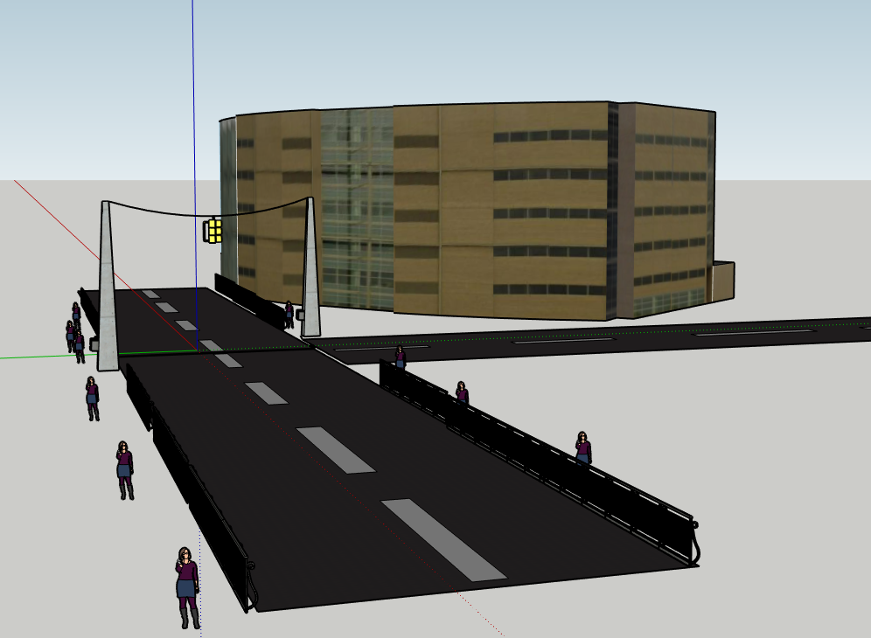

*Figure 3. CAD Model of Traffic Light with Fencing*

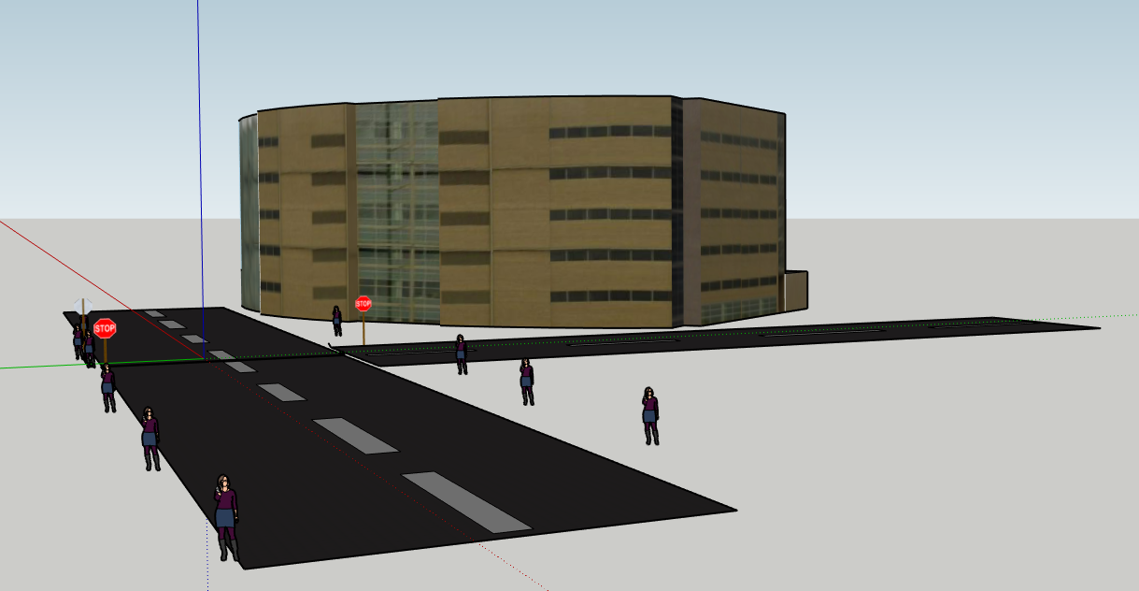

*Figure 4. CAD Model of All way stop signs*

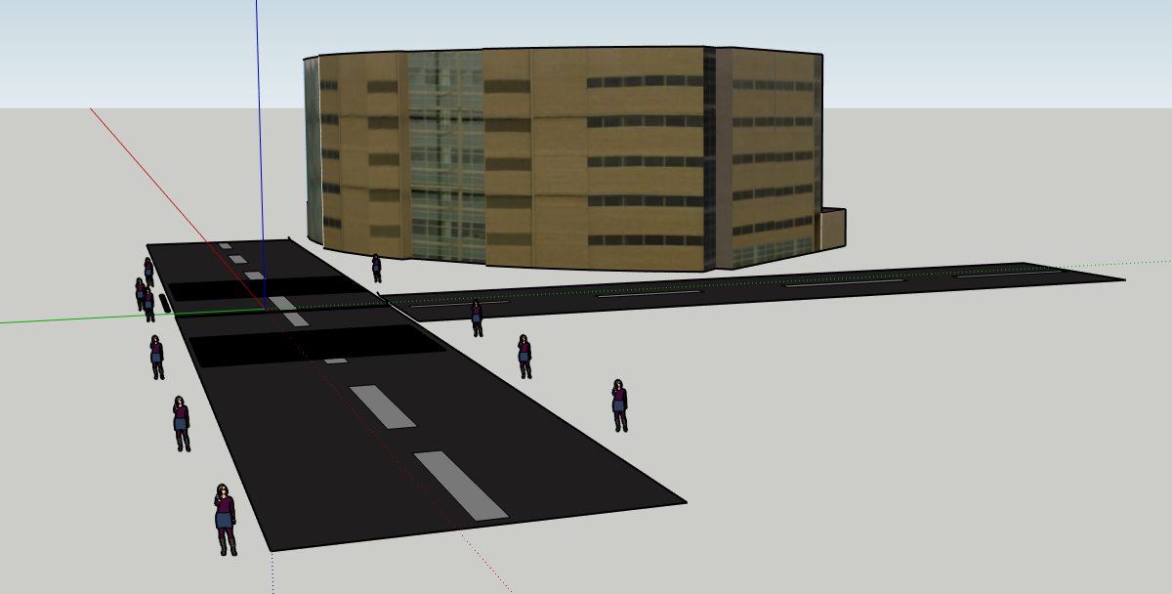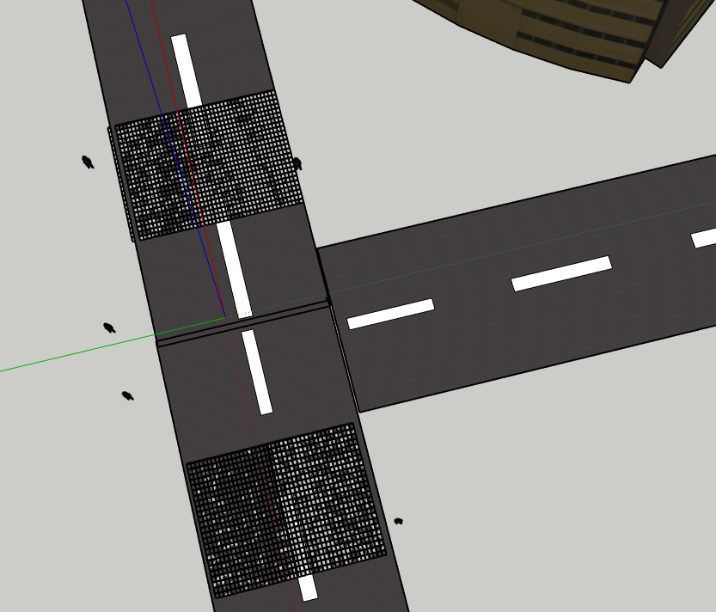

*Figure 5 and 6. CAD Model with Rumble Strip*

## Prototype Testing Protocol

We tested our prototypes by taking notes of how other intersections with similar traffic flow and density behaved with our ideas. We then took data on the safety, estimated cost, weight times, traffic, amount of J-walkers, and types of pedestrians we found there all in a comparative 0-10 scale. So first we looked at surrounding intersections where two roads met in an uppercase-T shape and then we found locations that either had a Stop-All-Way system in place or a light. There are many intersections with lights, so we narrowed it down to two that were most similar to our intersection. The first was the intersection of State Street and university street, although the intersection included a road that was far more busy with cars, the layout of the sidewalks and lights were perfect and the volume of bikers and pedestrians was very similar to our intersection. The next intersection we found was third street and university street, this location had lights and the roadway although not being similar in shape was very similar in traffic flow and volume to our intersection.

For the Stop-All-Way signs we could not find any place on campus that had them and had a similar volume of traffic and pedestrians. So we could not find any real way to test this. The only thing we could do was go back to our original data for the intersection of second street and university street. During busy times between classes every car stopped at the yield for traffic signs on university street, and second street already has a stop sign. So we could reasonably assume that the current mix of yield and stop signs would essentially act as a stop all way system when the pedestrian volume is high. Not only that, but having a yield sign instead of a stop sign on university street freed up traffic during the less busy hours because there were no pedestrians to stop for so the drivers could drive through with only a slight reduction of speed. The one main question we had left is safety, and without an actual stop all way intersection somewhere on campus it is impossible for us to make any accurate assumptions about that aspect.

Our third solution was a guard rail separating the pedestrians from the road to stop or at least limit J-walking. This is not used around any similar T-shaped intersection but it is used around the northern strip of northwest ave near mackey arena and along the westward side of northwestern ave along the Neil Armstrong Hall of Engineering.

## Test Results for Top 4 Alternatives

*Table 11. Results for our Top Alternatives*

**Intersection Safety Amount of Traffic Amount of Pedestrians J-Walkers**

**2nd & Univ. (M)** 3 3 5 7

**State & Univ. (TL)** 7 7 5 1

**3d & University(TL)** 2 3 9 10

**Northwestern Av.(R)** 10 8 2 0

***M=Main Intersection, TL=Traffic Light, R=Railing***

We decided to take comparative data simply because it was easier to do than to try and create complicated metrics for each criteria and then try to force them all together in a twisted and hard to understand document. This is far easier to compare and the data is very telling. The first thing that sticks out is that the intersections that have low J-waker scores have high safety scores and vice versa, this is obviously because most of the unsafe things we witnessed where interactions between pedestrians and drivers when the drivers had the right of way but the pedestrians went anyways. Next the volume of pedestrians that is most similar to the intersection of University and 2nd street is State and University, most likely because like the intersection of 2nd and University street this intersection connects two major areas of academic buildings. The next intersection was 3d and university, its drawback was that at this location there are far more pedestrians and bikers and at least two to three times as many J-walkers, but the traffic flow was very similar in volume. We collected data from both but it does not seem like a totally accurate set of data to compare to the intersection of university and second street. Finally there was Northwestern Ave, here it is very obvious that the guard rail separating pedestrians stops people from J-walking and we did not witness any unsafe moments or close calls between drivers and pedestrians.

## Weighted Decision Matrix (WDM)

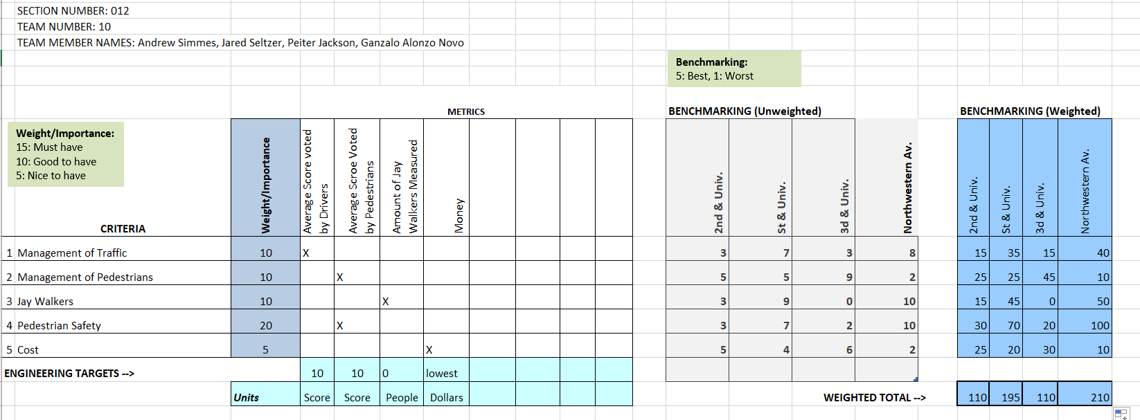

*Figure 7. Weighted Decision Matrix*

In our WDM, we compared all of the streets in Purdue with a similar structure to that of our prototypes in order to decide which solution was better. In addition, we measured the criteria and constraints, giving them a value based on their importance to calculate the overall best solution. After inputting all the values for each of the categories, the largest value, thus the best possible solution, was the Northwestern Avenue solution, which corresponds to the railing and traffic light solution. This actually matches our thoughts from the visual experiment, as it clearly is the most safe regarding accidents, and the one with the least traffic. On the other hand, this was also by far the most expensive solution, which surprisingly ended up not influencing the final decision of our WDM.

# ITERATION #2

*Table 12. Responding to feedback*

|  |  |  |
| --- | --- | --- |
| **#** | **Based on feedback/data from … about …** | **We made changes in…** |
| 1 | Based on feedback from our own team about the speed bump solution | We made changes in it by choosing a variation of that, the rumble strip. |
| 2 | Based on the feedback from our observations and interviews about the safety on the street we were given | We made changes in our final prototypes, by adding fences to the traffic light prototype. |
| 3 | Based on feedback from our own team about the economic implications of our solution | We made changes on the traffic light prototype, changing it to one single light |

# OVERVIEW OF FINAL DESIGN

## Detailed Design



*Figure 8. CAD Model of the Intersection with Fences and Lights*

## Data on Final Solution

By adding a set of railings on either side of University street and a traffic light we can make the intersection safer than it already is. We measured our solution by looking at other locations with those select characteristics: Railings, stop lights, and stop all way signs. We gave a score of 0-10 for each characteristic of the intersection We saw how on the intersection of 3d & University the traffic light was good at limiting the traffic flow, with a score of three, it had more issues with J walkers at a 10. And we saw the quarter mile span of Northwest Avenue that had railings which greatly limited the number of J-Walkers with a score of 0, but also had a lot of traffic at 8. What these show is that with a traffic light the car traffic will be limited and that is a necessity, but without another tool to stop J-Walkers the intersection will not be more safe. If an intersection had both a system of fences and a traffic light it would combine to have the benefits of the two solutions.

*Table 12. Data on our final solution*

**Intersection Safety Amount of Traffic Amount of Pedestrians J-Walkers**

**\*2nd & Univ. (M)** 3 3 5 7

**State & Univ. (TL)** 7 7 5 1

**3d & University(TL)** 2 3 9 10

**Northwestern Av.(R)** 10 8 2 0

1. **Design Optimization**

We attempted to optimize our solution by combining multiple solutions together to get their combined benefits. So we wanted to use a traffic light to help with the traffic volume problem along with a series of railings to stop the pedestrian issues with overcrowding and j-walking.

## Novel Aspects of the Solution

Although many solutions similar to this are used across the US, most do not implement it in the same way as we do. Most of the time, when there is a traffic light on a main road, there are no railings like there are in our solution. The people who designed the other intersections did not have to worry about a population of students who do not care whether they are actually allowed to cross or not. Because of this, we are suggesting the addition of rails in addition to the traffic light. The traffic light will allow for the students to cross safely, and when they don’t have the right of way, the railings will hopefully cut back on the amount of jaywalking the students will do.

## Trade-off Decisions and Limitations of the Solution

One trade off for our solution includes that we have expensive solutions. It will cost a lot of money to add a stoplight as well as a pedestrian railing. In addition to this, the stoplight will slow down traffic when there are not a lot of pedestrians using the crosswalk. A possible, yet unlikely, unexpected problem that can occur is people ignoring the cross signals and J-walking more despite the railings, creating a more dangerous intersection.

## Lessons Learned

Our team excelled in our sketches, idea generation, and problem scoping. Our sketches were well developed and a good representation of what we wanted the intersection to look like. We had lots of ideas, giving us many ideas to explore and choose from. Finally, we did good problem scoping to really understand the problem at hand, specifically at our intersection. We need to work on prototypes and supporting data. Getting more detailed prototypes will help us further explore if solutions are viable. In addition to prototypes, we need more detailed data to further support our decision to use stop lights and railing.

# REFERENCES

Zwane, G. (2015, November 26). Disadvantages associated with speed bumps. Retrieved from <https://sandtonchronicle.co.za/136836/disadvantages-associated-with-speed-bumps/>.

Are Radar Detectors Worth It And Do They Work (2019). (2019, September 13). Retrieved from <https://www.ratedradardetector.org/blog/are-radar-detectors-worth-it/>.

Myszkowska, A. (2019, July 8). Dedicated cycle lanes in Scotland – Pros & cons. Retrieved from <https://watermans.co.uk/pros-cons-dedicated-cycle-lanes/>.

Perry, N. (n.d.). Pros And Cons Of Traffic Lights. Retrieved from <https://www.ccsegarra.com/pros-and-cons-of-traffic-lights/>.

Newberg, S. (2014, May 21). The Great Stop Sign Experiment. Retrieved from <https://streets.mn/2014/05/21/the-great-stop-sign-experiment/>.

Traffic light flat icon stoplight and navigation vector image on VectorStock. Retrieved from <https://www.vectorstock.com/royalty-free-vector/traffic-light-flat-icon-stoplight-and-navigation-vector-17866514>

Zebra Crossing Light Product on Alibaba.com. (n.d.). Retrieved from <https://www.alibaba.com/product-detail/China-Zebra-Crossing-Dynamic-pedestrian-led_60778888304.html>.

Traffic light flat icon stoplight and navigation vector image on VectorStock. Retrieved from

<https://www.vectorstock.com/royalty-free-vector/traffic-light-flat-icon-stoplight-and-navigation-vector-17866514>

In-Plant Stop Sign. (n.d.). Retrieved from <https://www.emedco.com/stop-sign-dk155-78251.html?utm_campaign=PC-01-Safety&FacilitySigns_WarehouseSafetyLowPriorityNEW_Emedco_PLA_NB_C_Google_US&utm_source=google&utm_medium=cpc&utm_term=&matchtype=&device=c&adgroupid=In+Plant+Traffic+Signs&keycode=WB0139&gclid=EAIaIQobChMImo2v-7DU5QIVia3tCh2qcQwuEAQYASABEgJJhfD_BwE&gclsrc=aw.ds>.

In-Plant Stop Sign. (n.d.). Retrieved from <https://www.emedco.com/stop-sign-dk155-78251.html?utm_campaign=PC-01-Safety&FacilitySigns_WarehouseSafetyLowPriorityNEW_Emedco_PLA_NB_C_Google_US&utm_source=google&utm_medium=cpc&utm_term=&matchtype=&device=c&adgroupid=In+Plant+Traffic+Signs&keycode=WB0139&gclid=EAIaIQobChMImo2v-7DU5QIVia3tCh2qcQwuEAQYASABEgJJhfD_BwE&gclsrc=aw.ds>.

Solar Horizontal Rapid Flashing Beacon System with Push Button Activation. (n.d.). Retrieved from <https://ledlighting-solutions.com/solar-horizontal-rapid-flashing-beacon-system-with-push-button-activation.html?matchtype=&network=g&device=c&keyword=&campaign=1349580909&adgroup=pla-819970055922&gclid=EAIaIQobChMIiNSXnrHU5QIViKztCh223AfmEAQYBiABEgKYf_D_BwE>.

Traffic Signals. (2004, April). Retrieved November 18, 2019, from <https://www.google.com/url?sa=t&rct=j&q=&esrc=s&source=web&cd=17&ved=2ahUKEwiypNO2iP7lAhUjMX0KHV6ID5YQFjAQegQICBAC&url=http://library.ite.org/pub/?id=e26c7ce7-2354-d714-51f1-3bf5311d7c2a&usg=AOvVaw0jKDxw4F8upDkaAS40WkXj>.

# APPENDICES